BASH SCRIPTING
Script : 1
Automating the daily sanity test in organisation
Step 1: Create and insert text into test using vi
Inside vi:
- Press i (enter Insert mode).
- #!/bin/bash (should be enterd on line 1)
- memory in megabytes from free -m
- all running processes from ps -ef
- disk total/used/available from df
- disk size used by directories du -su*
- Press Esc (leave Insert mode).
- Type : wq! and press Enter (write & quit).
- chmod 777 or chmod 755 tech giving permissions
- Then execute using ./tech
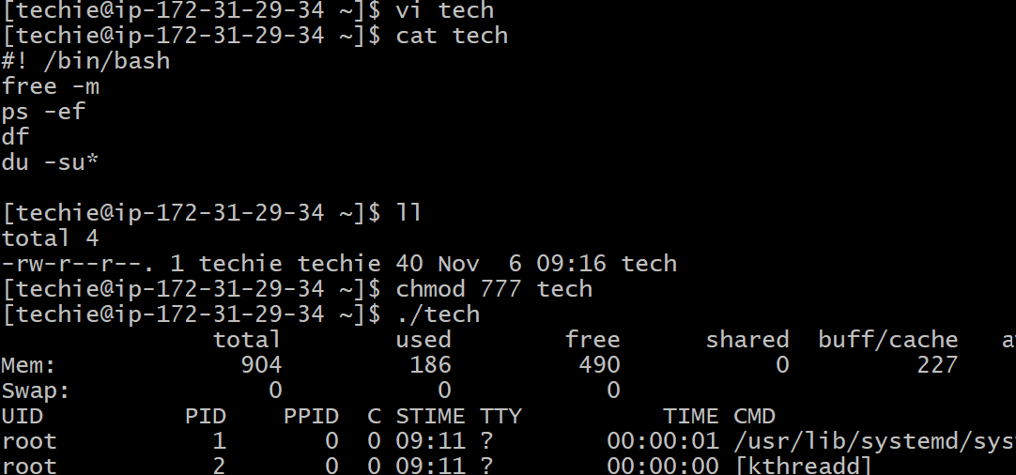
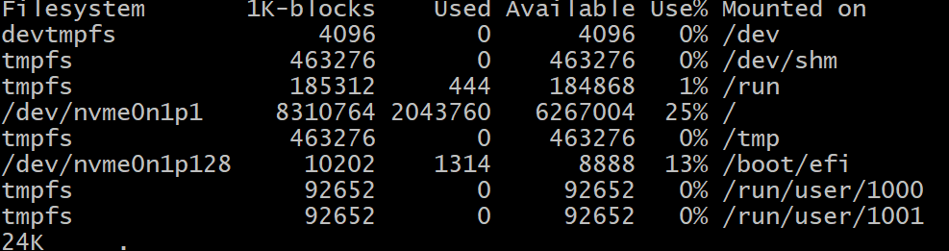
Script 2:
Sequence script:

Script will execute from top to bottom

follow script 1 steps to execute

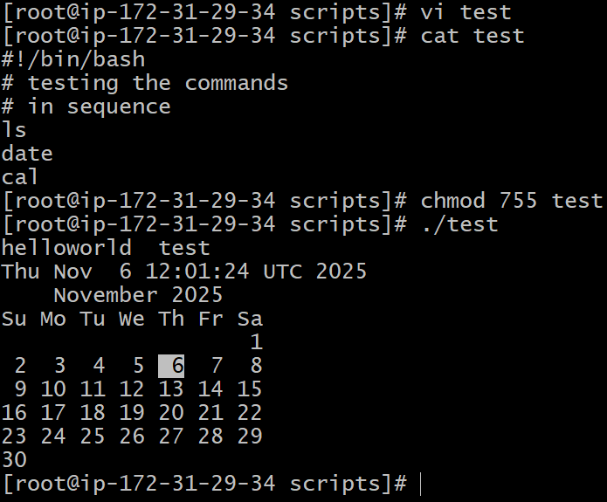

Script:3
Testing commands basis of sequence

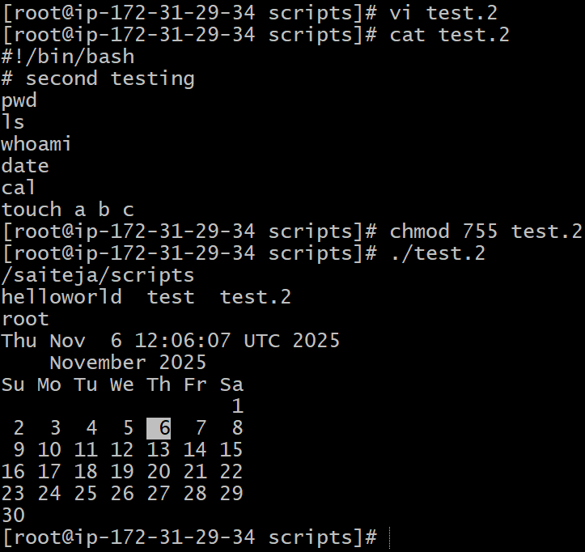

We are created 3 files using touch a b c it was the last command so that it couldn’t displayed the files name on ls command output
For that we need to again ls for listing
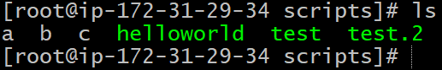

Script :4

Basic Administration Tasks:

same steps as first script

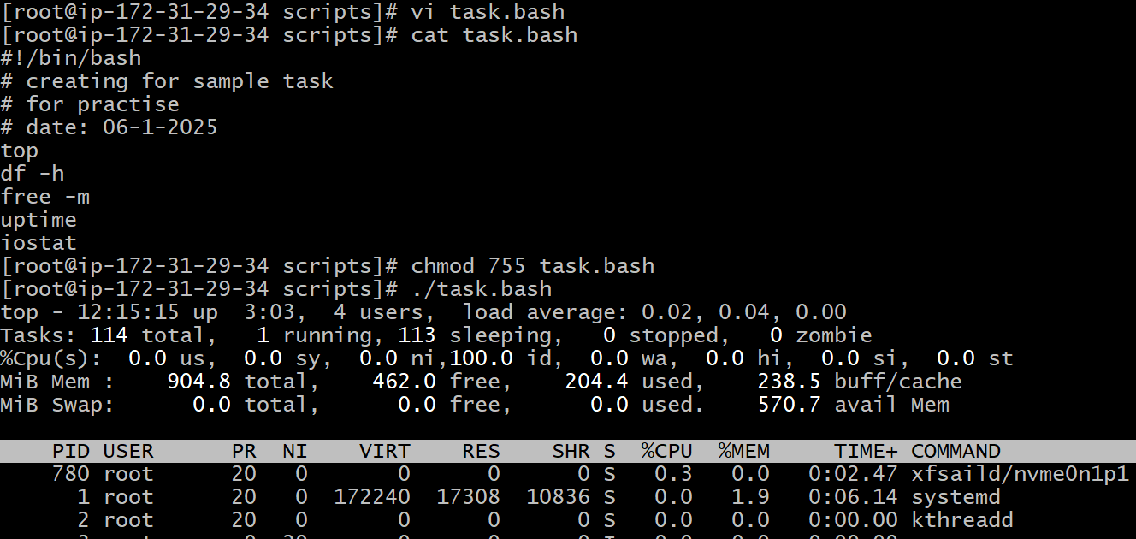

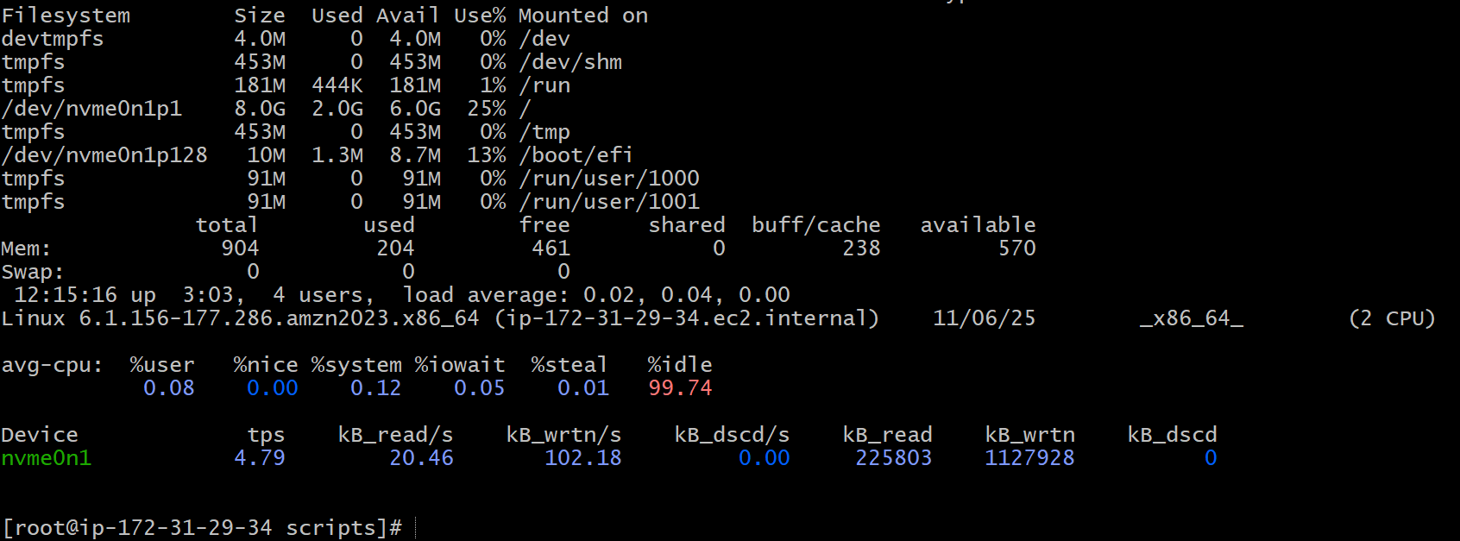

Script:5

Basic Administration Tasks:
top | head -10 ( only captures first 10 lines)

If we use top command get stucks because that will conitnously montior.

use top | head -10
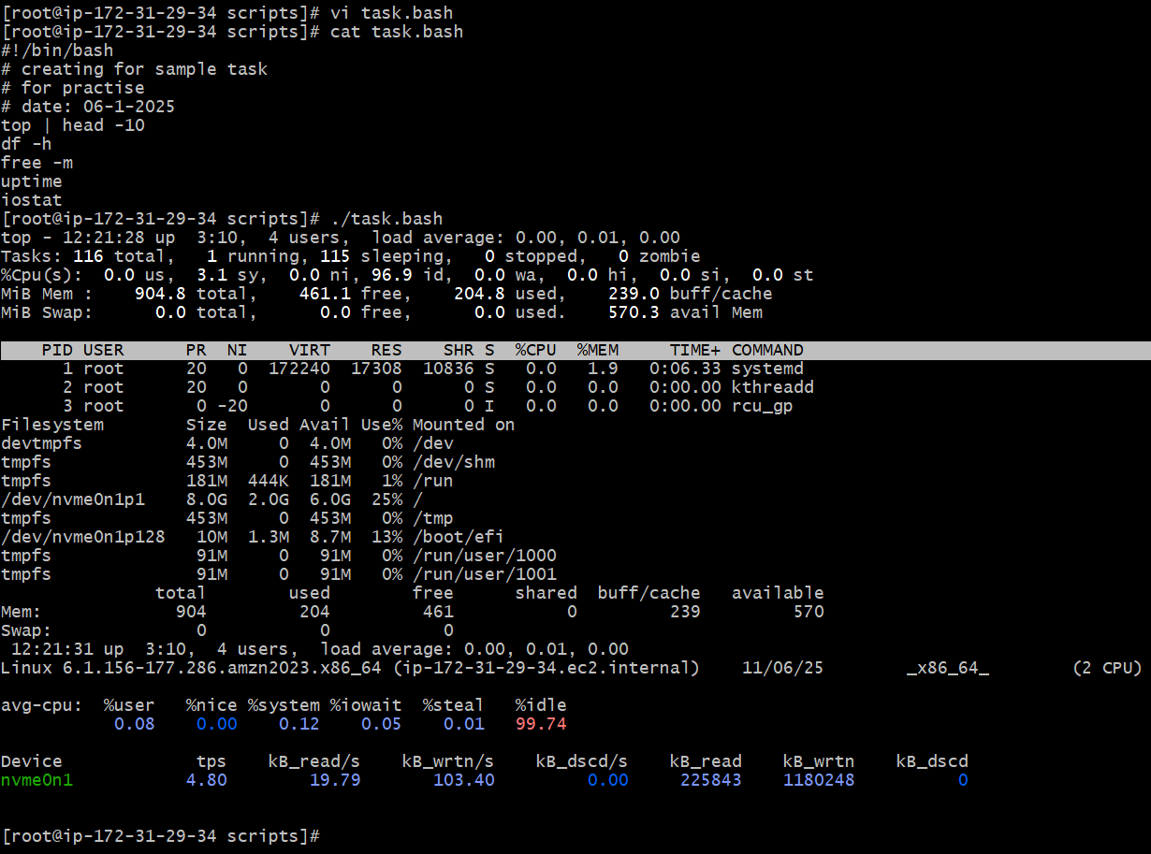

Script:6

Defining Variables
(we are providing variables to commands like p=pwd )

After using vi use cat to entered data into it

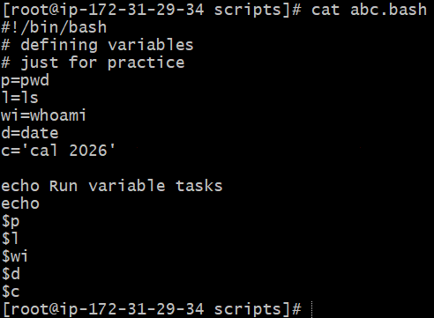

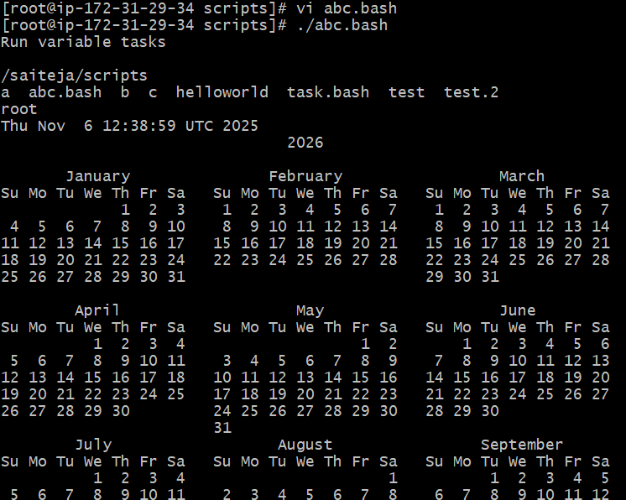

Script:7

Input and output commands
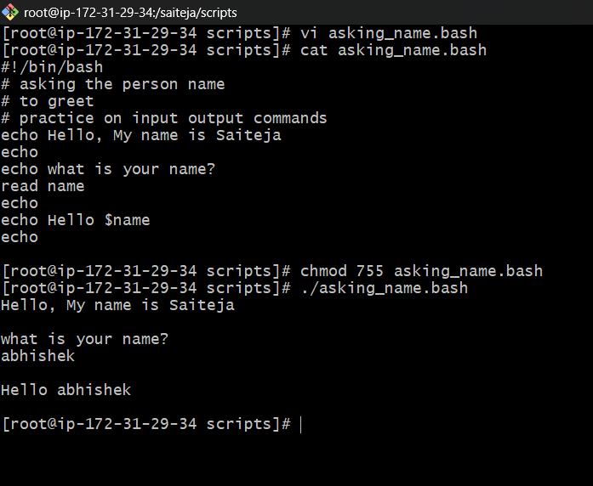

Another example here I also mentioned what is your qualification

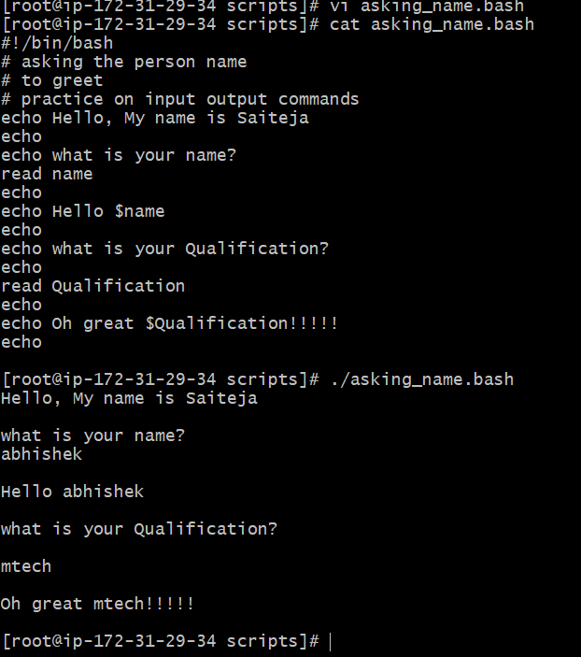
Script:8
Using ` `(back ticks) marks

In the command line (Bash, sh, etc.), backticks are used to execute a command inside another command — this is called command substitution

In the below screenshot hostname as got some ticks like `hostname`
So that the output is ip address if we doesn’t mention ` back ticks` marks then host name will be hostname see in 2nd screenshot

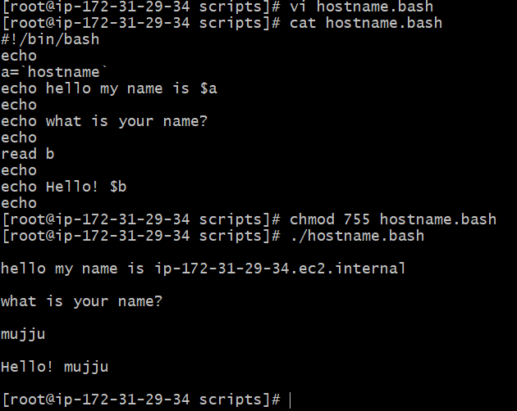

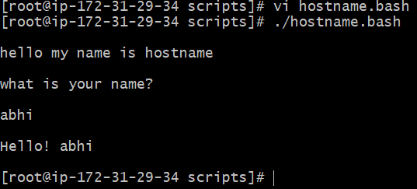

` called as backtick

Script 9:
Verifying of age to vote or not

